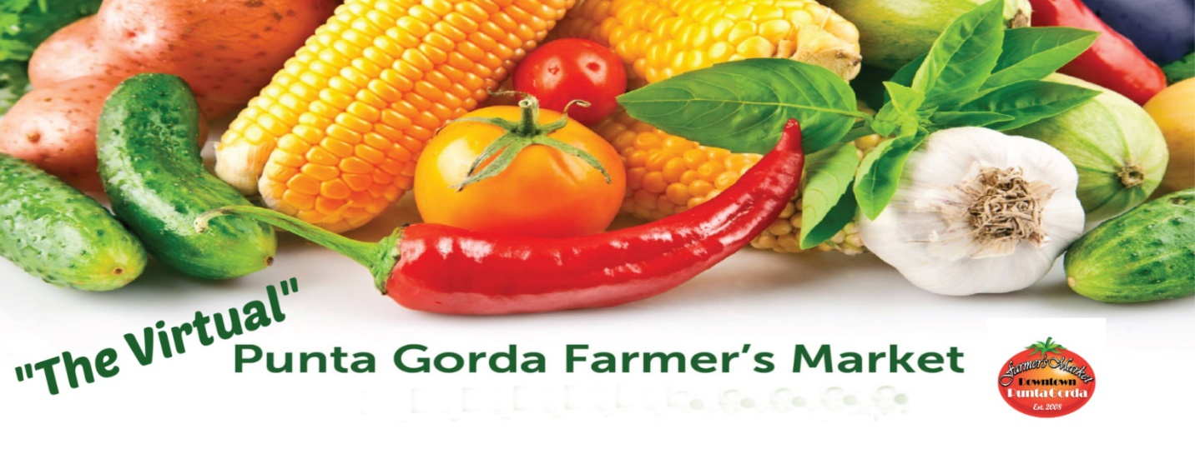
How to Shop at “The Virtual” Punta Gorda Farmer’s Market
Q. What is “The Virtual” Punta Gorda Farmer’s Market?
A. “The Virtual” Punta Gorda Farmer’s Market is an online Farmer’s Market that provides it’s customer’s the opportunity to order and pick-up “essential” products, (as established by state and government CCOVID-19 regulations) normally sold at the Punta Gorda Farmer’s Market.

Q. Who are the participating “Essential” Vendors.
A. The Happy Pickle; Natures Tech; Tropical Island Kettle Corn; Weil Farms; Maria’s Italian Kitchen; Baca Bread; Mapri Services; The Country Gardener; Lobster rolls ; Jimmy’s Java; Eileen’s English Toffee; Irene’s Produce; Dynasty Guacamole; Fresh Power Smoothies; Chocolate/wine shop; Paradise Gourmet; Greek Cliché; Nick B’s Chimichurri; Licorice twists; Ichabod Spice Company; Hernandez Produce; G-Bones, Jams, Jellies; Grammies Cakes;
Provida; Monte Reale; Karinas Kitchen; Shellback Trading Co.; Bella PASTA; Village Market; Curries Smokin Hot BBQ

Q. How do I order products from “The Virtual” Punta Gorda Farmer’s Market?
A. Access the Vendor’s website online or contact via phone call to order and purchase products.
Q. Is there an order placement deadline?
A. All orders must be placed to the Vendor by Thursday midnight.

Q. When and Where can I pick up my order?
A. Orders MUST be picked up on Saturday between 10am-1pm at 209 West Olympia Avenue, Punta Gorda (Across from the Market)

Q. Can I pay for my purchase at “Pick-Up?”
A. No. ALL purchases must be paid for at the time of product order from the Vendor.

Q. Do I need a receipt to pick-up the purchased product?
A. Yes, please bring your receipt for the purchased product and ID.

Q. If I cannot pick up my order, will I receive a refund?
A. There are NO REFUNDS on product orders that are not picked up between 10am-1pm on Saturday. No products will be held after Saturday after 1pm.

Q. I have a question about my order, who should I contact?
A. All questions about your product order must be directed to the Vendor.

