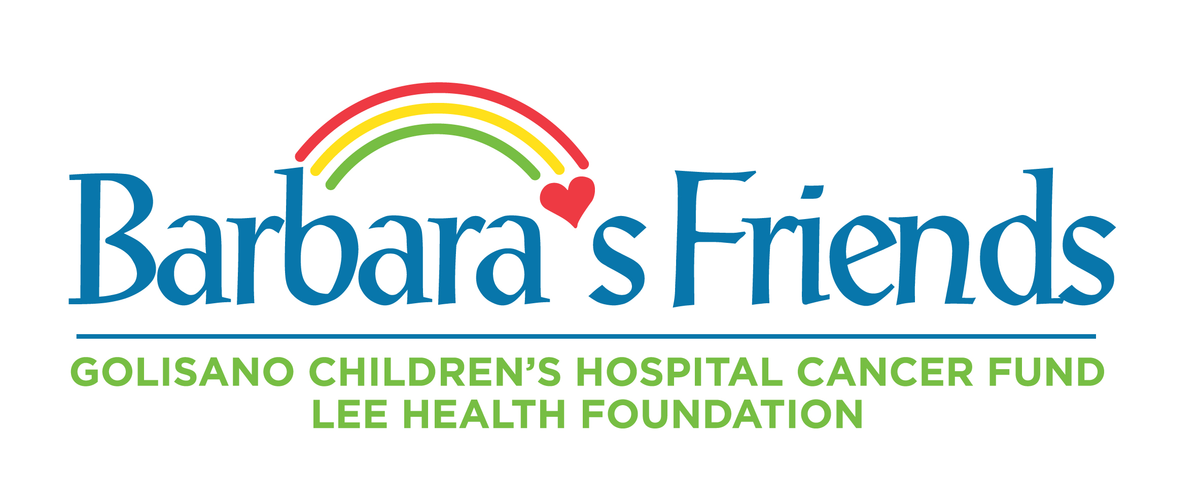
FOR IMMEDIATE RELEASE
DOWNLOAD LINK: PHOTOS, VIDEOS

Frank Haskell, 93, local hero for children with cancer, dies
Haskell co-founded Barbara’s Friends, Golisano Children’s Hospital Cancer Fund, which has raised $25 million since 1995
FORT MYERS, Fla. (July 19, 2023) – Frank Haskell, 93, co-founder of Barbara’s Friends to support children with cancer, passed away on Wednesday, July 19. For the past 28 years, Haskell worked tirelessly to help local children win their battles with cancer and life-threatening blood disorders. Through his efforts, Barbara’s Friends raised $25 million to support more than 10,000 children at Golisano Children’s Hospital.
“Without Frank Haskell, the achievements we’ve made to advance pediatric cancer care in Southwest Florida would not be possible,” said Dr. Emad Salman, VP and Chief Physician Executive – Children’s Services. “Frank was committed from the moment I met him to making a difference. He has saved the lives of thousands of children, forever impacting their families and our community. His passion and tenacity and humor will be missed. Frank was a true champion and friend to all children.”
Haskell retired in 1987 and relocated to Southwest Florida after a successful career at Burroughs Corporation in Boston, where he was the youngest vice president in company history, and Moore Business Systems in Dallas. He was invited to join the development board for the Children’s Hospital of Southwest Florida in 1991.Haskell founded the cancer fund with his late wife Betty in 1995, naming the fund in memory of their daughter Barbara, who died at age 36 after a battle with cancer. Before Barbara died, she asked her parents to do more to help children fighting cancer, so they didn’t have to suffer. The original goal was to raise about $100,000 with the fund in her name.
“Today, to have this wonderful facility is the greatest thrill of my life,” Frank Haskell once said from the Cypress Cove apartment where he lived since 2011 overlooking Golisano Children’s Hospital. “Losing a child of your own before you go is a devastating thing to have happened. This has kept her life ongoing. I think of her every single day.”
The Barbara’s Friends Medical Library was established at HealthPark Medical Center in 1998. Barbara’s Friends Pediatric Hematology Oncology Center on the fifth floor of HealthPark opened in 1999 to serve children until Golisano Children’s Hospital was built in 2017. The Barbara’s Friends permanent endowment was established in 2002.
Through a strong personal relationship, Haskell and former Boston Red Sox president John Harrington also founded the golf tournament in 1994 that has raised $15 million to date for programs at Golisano Children’s Hospital. Haskell’s ties to the Red Sox started in 1993 when he was hired by the team to operate the scoreboard at the Red Sox former spring training home at City of Palms Park. He was honored by the Red Sox at Fenway Park on his 80th birthday.
In recognition of his service to the community, Haskell was named The News-Press Luminary in 2015. In 2016, Lee Health Foundation established The Frank Haskell Humanitarian Award in his honor to recognize outstanding leadership in the advancement of quality health care for the citizens of Southwest Florida.
Haskell helped establish Barbara’s Friends scholarships in 2020 that are awarded annually to high school students who are childhood cancer or blood disorder survivors. So far, seven students have received scholarships.
Barbara’s Friends funding also helped create Palmer the Turtle stuffed animals, coloring books and medical books, designed to entertain, comfort and educate cancer patients and their families. In March, the Haskell family donated the Haskell Total Immersion Room in Frank’s honor at the Naples pediatric hematology oncology clinic, the only one in the country, offering children receiving chemotherapy and infusions a totally immersive virtual reality escape during treatment.
In Haskell’s honor, Barbara’s Friends will continue to advocate for children with cancer in Southwest Florida, by raising funds to support exceptional care at Golisano Children’s Hospital. For information, visit BarbarasFriends.org.
About Barbara’s Friends – Helping Kids with Cancer at Golisano Children’s Hospital
Established in 1995, Barbara’s Friends provides equipment, staffing and services to support lifesaving cancer care for children from across Southwest Florida at Golisano Children’s Hospital. The Pediatric Hematology/Oncology Program is the only program of its kind in Southwest Florida and has served more than 10,000 patients since opening. No child is denied treatment or turned away due to their family’s inability to pay for care. For more information about the Barbara’s Friends fund and supporting child patients in your community, please call Lee Health Foundation at (239) 343-6950 or visit BarbarasFriends.org.
About Lee Health Foundation
Lee Health Foundation raises philanthropic dollars on behalf of Lee Health to establish, expand and enhance innovative, lifesaving and preventative programs. The Foundation provides financial support for all five hospitals as well as many service areas including Lee Health Cancer Institute, Lee Health Coconut Point, The Rehabilitation Hospital, Lee Health Heart Institute, Community Health Clinics and Golisano Children’s Hospital Specialty Clinics in Port Charlotte and Naples. For more information, please visit LeeHealthFoundation.org.
– END –
Media Contacts:
Tiffany Whitaker, APR, CPRC, Lee Health Foundation, Tiffany.Whitaker@LeeHealth.org, 239-343-6105 or 239-671-0724 (cell)
Kathy Becker, Priority Marketing, kathyb@PriorityMarketing.com, 239-267-2638 or 239-470-2681 (cell)

